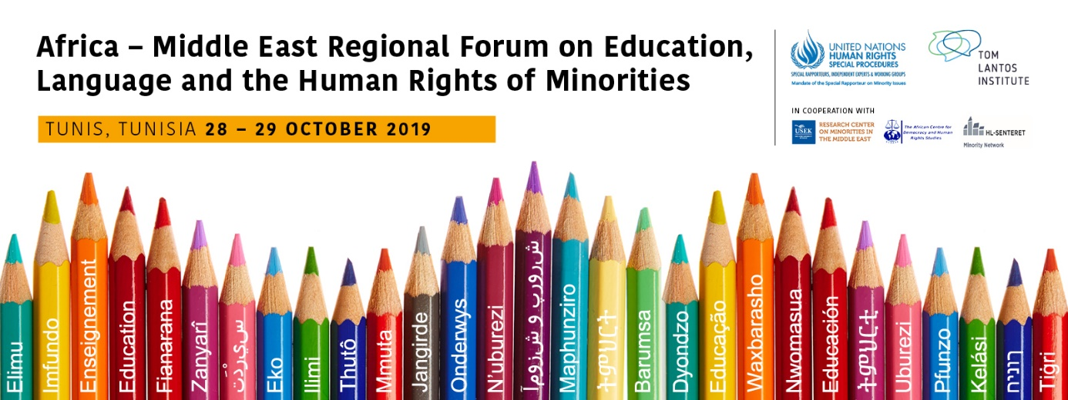

Guide to the Themes

The points below explain in more detail each key theme and working group.

Working Group 1 - Human Rights and minority language education

Is there a right to education in and teaching of a minority language, and if so to what extent and under what conditions? This is one of the central issues for many minority communities around the world and those instruments that do exist tend to still be fairly general, open to interpretation, or even misunderstood, particularly in relation to the relationship between human rights obligations and the use of (minority) languages in education.
This theme and working group will discuss the interaction between existing human rights standards and education in minority languages, considering the extent and/or conditions for such rights claims. It will also look at what minorities actually want when it comes to the teaching of and in their languages, as well as what States can provide when considering the principles of proportionality and reasonableness.

Working Group 2 – Public policy objectives and practices for education in minority languages

The implementation of human rights resulting in education in and teaching of minority languages can take many forms.
This theme and working group will consider how public policies should address the effective implementation of the human rights for minorities in the use of their languages in education. It will also discuss minority language institutions including the various types of schooling (integrated, separated, bilingual, multilingual), as well as minority language education’s relationship to economic and social development and the acquisition of the majority/official language.

Working Group 3 - Effective practices in education in and teaching of minority languages, including resources and management for the effective implementation

Beyond purely human rights or public policy considerations, it is essential to keep in mind the pedagogical value and significance of teaching in minority languages, and the impact this may have in learning outcomes for minority children, as well as on their interaction with other members of society.
Furthermore, having a right to education in a minority language is meaningless if appropriate resources and effective approaches are not in place. There can be a variety of obstacles of a practical nature to the effective implementation of human rights in education for minorities. Widespread misunderstandings need to be dispelled, particularly on the cost-effectiveness of education in minority languages.

