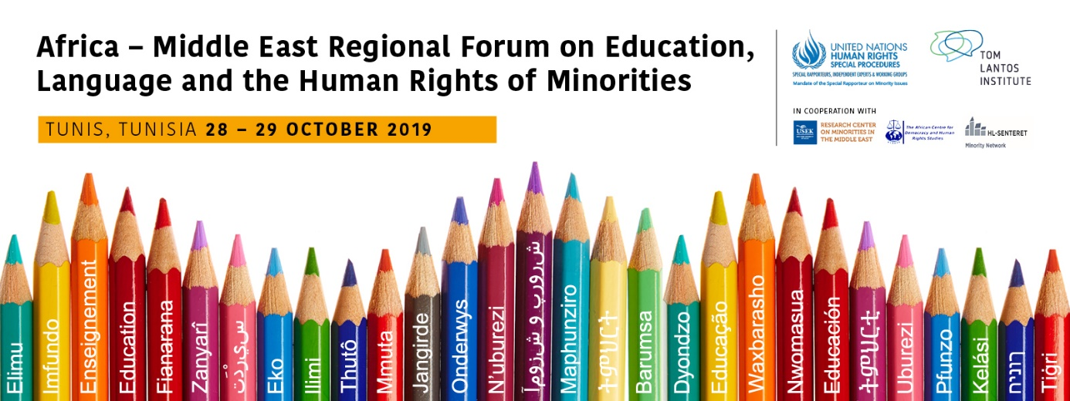

MONDAY 28TH OCTOBER

10:00-11:00 Opening Session

Welcoming remarks
- Anna-Mária Bíró, Director of the Tom Lantos Institute (5 minutes)
- Father Jean (Roland) Akiki, Director of the Research Centre on Minorities in the Middle East (5 minutes)
- Ingvill Thorson Plesner, Researcher and Network Coordinator, Norwegian Center for Holocaust and Minority Studies (5 minutes)
Keynote Speeches
- Ms. Elodie Cantier-Aristide, Representative of the Office of the High Commissioner for Human Rights in Tunisia (10 minutes)
- Fernand de Varennes, United Nations Special Rapporteur on Minority Issues (10 minutes)

Introductions, Rules and Guide to Proceedings (10 minutes)
Anna-Mária Bíró, Director of the Tom Lantos Institute, will set-out the process, explain the rules of proceedings and moderate the introduction of participants who, if they wish, will very briefly introduce themselves to the regional forum.

11:00-11:30 Coffee Break

11:30-12:30 Special Rapporteur on Minority Issues: Mandate and Work
Dr Fernand de Varennes

The session is moderated by Anna-Mária Bíró
In this session, the Special Rapporteur on minority issues will give a presentation on the scope of his mandate and work. Following the presentation, there will be an opportunity for questions and answers.

12:30-13:30 Lunch Break

13:30-14:45 Working Group 1: Human Rights and minority language education
The session will be moderated by Anna-Mária Bíró.
Expert: Nurcan Kaya (Turkey) and Fethi Ben Maamar (Tunisia)
Is there a right to education in and teaching of a minority language, and if so how should the right be implemented? This is one of the central issues for many minority communities around the world. While some instruments address the issue, these tend to still be fairly general, open to interpretation, or even misunderstood, particularly in relation to the relationship between human rights obligations and the use of (minority) languages in education.
This theme and working group will discuss the interaction between existing human rights standards and education in minority languages, considering the circumstances for such rights claims. It will also look at what minorities actually want when it comes to the teaching of and in their languages, as well as what States can provide when considering the principles of proportionality and reasonableness.
- The session will start with a 30 minute presentation by Nurcan Kaya, outlining the issues to be discussed in the working group in order to develop and draft recommendations. It is envisaged that a minimum of 5 recommendations will be drafted on the topic.
- Following the introductory presentation, participants will have the opportunity to ask questions, make interventions and propose recommendations on the theme in an open dialogue.
- Participants will be invited to make their contributions by raising their hands.
- The moderator will select participants, ensuring that there is a broad and balanced range of interventions in terms of region and participants.
- Participants should try to focus their interventions on proposing, or discussing, recommendations as much as possible. Interventions will be limited to approximately 5 minutes, however this is subject to the number of participants that wish to speak.
- During the discussions, the proposed recommendations will be noted down as they are formulated. This will be visible for participants during the session on a screen so that comments and amendments can be made during the discussions.
- In the final 20 minutes of the session, the expert will read the list of proposed recommendations that have been formulated. This will be a final opportunity to discuss the recommendations on the topic, before they are finalised.

14:45-15:15 Coffee Break

15:15-16:30 Working Group 1: Human Rights and minority language education (continued)

Following further discussions, this topic will conclude with a summary of the draft recommendations that have been proposed.
TUESDAY 29th OCTOBER
09:00-10:15 Working Groups 2 and 3: Public policy objectives and effective practices for education in minority languages, including resources and management for the effective implementation
The session will be moderated by Anna-Mária Bíró
Experts: Lahoucine Bouyaakoubi (Morocco) and Nouha Grine (Tunisia)
The implementation of human rights resulting in education in and teaching of minority languages can take many forms.
This working group will consider how public policies should address the effective implementation of the human rights for minorities in the use of their languages in education. It will discuss minority language institutions including the various types of schooling (integrated, separated, bilingual, multilingual), as well as minority language education’s relationship to economic and social development and the acquisition of the majority/official language.
This session will also look beyond purely human rights or public policy considerations, as it is essential to keep in mind the pedagogical value and significance of teaching in minority languages, and the impact this may have in learning outcomes for minority children, as well as on their interaction with other members of the society.
Furthermore, the session considers the appropriate resources and effective approaches that are required to put in place effective implementation for the right to education in a minority language. There can be a variety of obstacles of a practical nature for the implementation of human rights in education for minorities.
It will also explore the widespread misunderstandings that need to be dispelled, particularly on the cost-effectiveness, and the societal benefits of education in minority languages should be highlighted.
The session will start with a 30 minute presentation by Lahoucine Bouyaakoubi and Nouha Grine, outlining the issues to be discussed in the working group in order to develop and draft recommendations. It is envisaged that a minimum of 5 recommendations will be drafted on the topic.
The same process will follow, as describe in Working Group 1 above.

10:15-10:45 Coffee Break

10:45-12:00 Working Groups 2 and 3: Public policy objectives and effective practices for education in minority languages, including resources and management for the effective implementation (continued)
Following further discussions, this topic will conclude with a summary of the draft recommendations that have been proposed.

12:00-13:30 Lunch Break

13:30-15:00 Concluding Session
The session is chaired by Ingvill Thorson Plesner
Overview of draft recommendations (30 minutes)
Nouha Grine will briefly summarise the draft recommendations proposed from each working group session. Participants will have a final opportunity to make any suggestions before the list of draft recommendations is officially closed.

Publication of forums documentation (10 minutes)
Marcus Oda, Program Manager at the Tom Lantos Institute, will outline the process for the publication of the regional forum documentation, and give an introduction to the website – Minority Forum Info - https://www.minorityforum.info/

Concluding remarks (30 minutes)
- Fernand de Varennes, United Nations Special Rapporteur on Minority Issues issues
Working languages: Arabic, English and French interpretation is available

